LAB 04
Department of Computer Science
BS Software Engineering
ABASYN UNIVERSITY PESHAWAR

Submitted By | Adnan khan
Roll Number | 25431
Semester / Section | 5th Semester / CB
Course Title / Code | SE 305
Submitted To | Mam Faryal
Submission Date | 10/22/2026

Task 1:
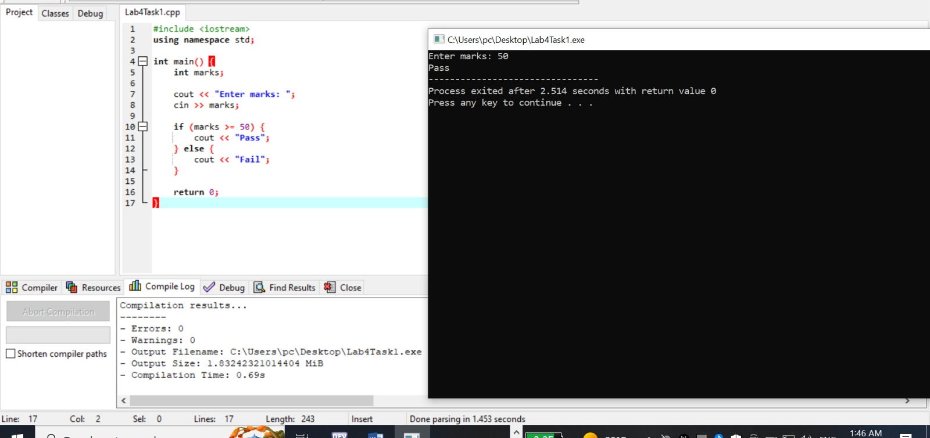
Task 2:
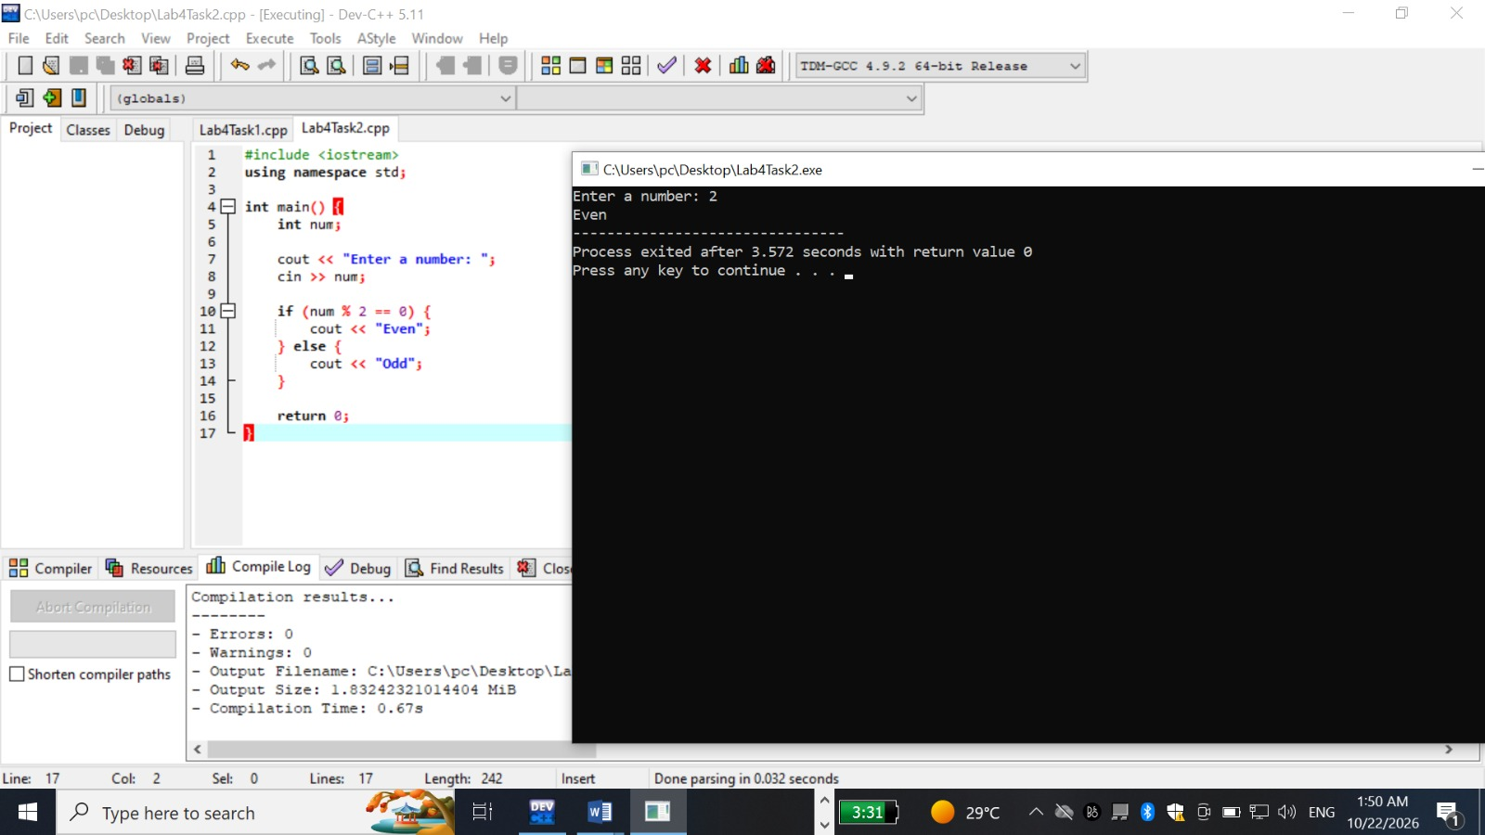
Task3
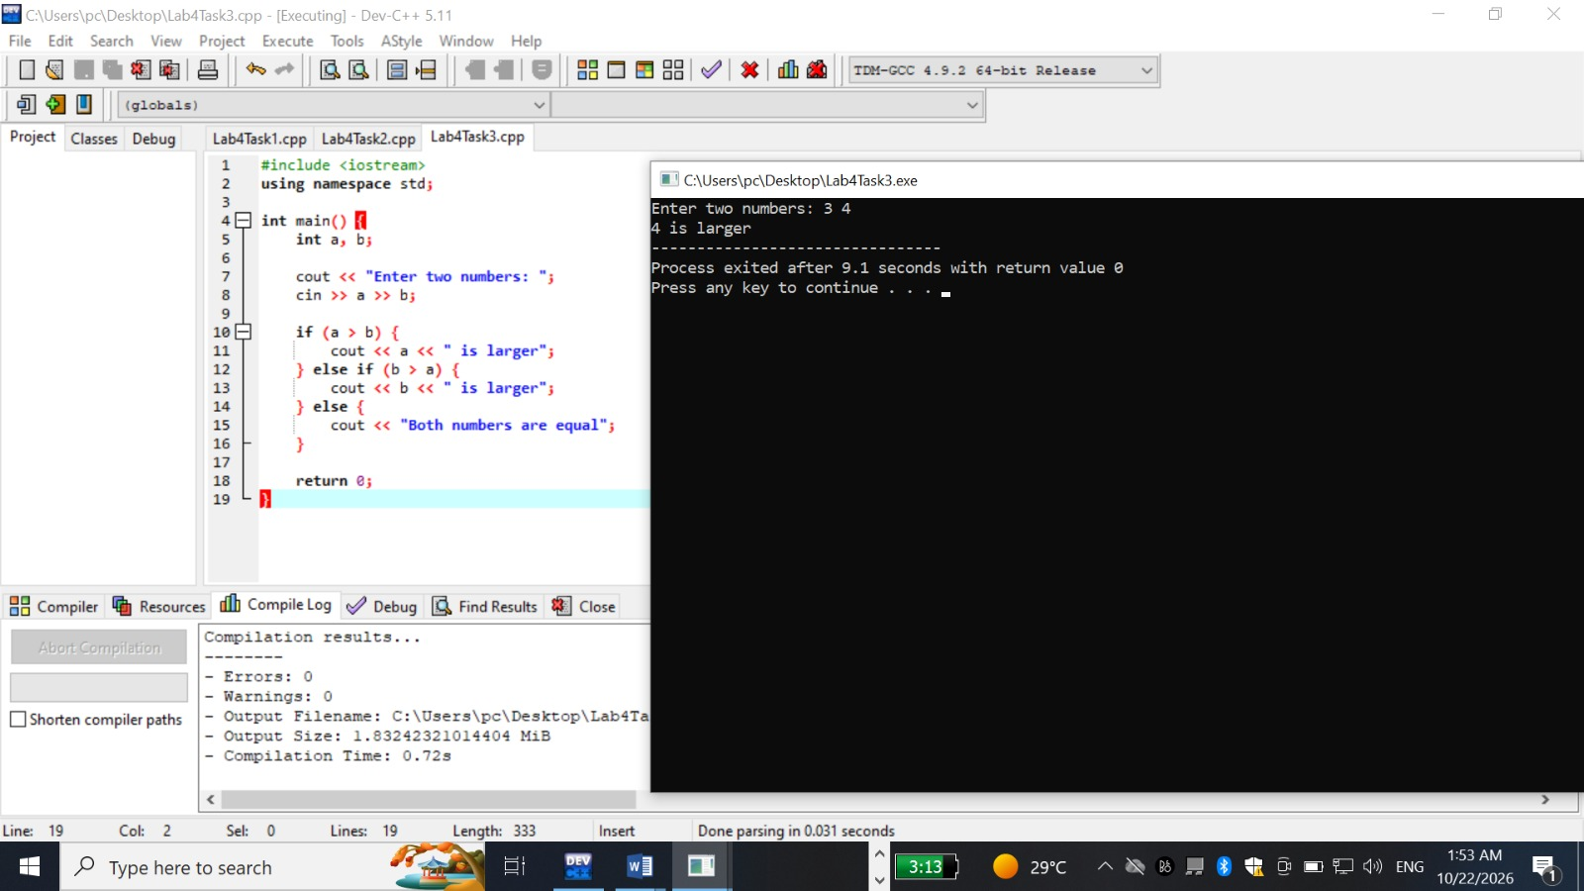
Task 4
For loop
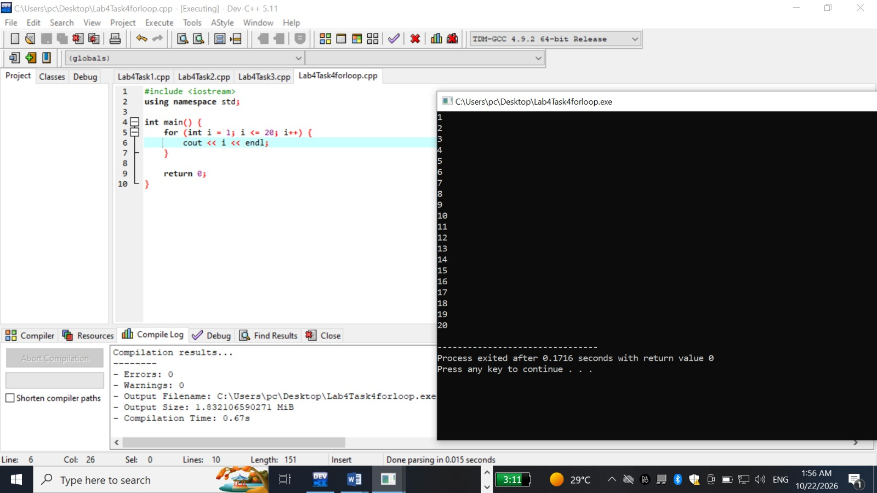

While loop
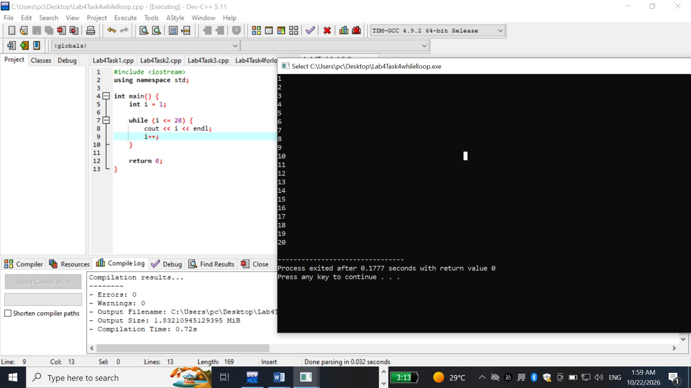
Task 5
